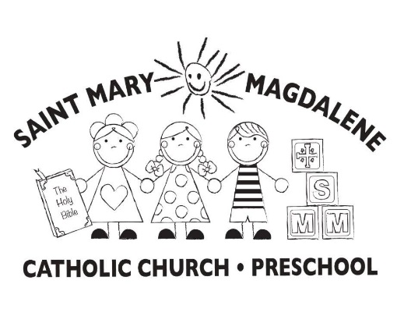
2023-2024 Preschool Calendar
We follow the Coweta County School Calendar
Calendar subject to change

August 28-September 7, 2023 Teacher Workdays/Staff Orientation/Pre-Planning
Thursday, August 31, 2023 First Aid/CPR Training
Wednesday, September 6, 2023 Parent Orientation Night 5-6pm (No students)
Thursday, September 7, 2023 Meet the Teachers-Student Visitation 10am-12pm
Tuesday, September 12, 2023 First Day of School for ALL students
Friday October 6, 2023 No Classes, Teacher Workday
Monday, October 9, 2023 No Classes, Columbus Day
Wednesday, November 1, 2023 No Classes, All Saints Day*
Monday, Nov. 20–Friday, Nov. 24, 2023 No Classes, Thanksgiving Break
Friday, December 8, 2023 No Classes, Immaculate Conception*
Monday, Dec. 18-January 2, 2024 Christmas Break
Monday, January 1, 2024 No Classes, New Year’s Day
Tuesday, January 2, 2024 No Classes, Teacher Work Day
Wednesday, January 3, 2024 Classes Resume
Monday, January 15, 2024 No Classes, Martin Luther King Day
Tuesday, January 16, 2024 No Classes, Teacher Training Conference PTC
Wednesday, February 14, 2024 Ash Wednesday (Beginning of Lent)
Monday, Feb. 19-Friday, Feb. 23, 2024 No Classes, Winter Break
Thursday, March 14, 2024 No Classes, Teacher Workday
Friday, March 15, 2024 No Classes, Teacher Workday
Thursday, March 28, 2024 No Classes, Holy Thursday
Friday, March 29, 2024 No Classes, Good Friday
Monday, April 1, 2024 No Classes, Easter Monday
Monday, April 1-Friday, April 5, 2024 No Classes, Spring Break
Monday, April 8, 2024 Classes Resume
Friday, May 10, 2024 Last day of school/Graduation Program
Monday, May 13, 2024 Teacher workday/close out classrooms
Tuesday, May 14, 2024 Teacher end of year meeting (post planning)

*Holy day of Obligation

All non-exempt employees working under 1,040 hours are not eligible to be paid for holidays per the Archdiocese of Atlanta Handbook.

